I require cable entry on the RIGHT
I require cable entry on the LEFT

Switch No. | Legend  (eg Front Spots) | Colour | L | M
1 LEFT
2 LEFT
3 LEFT
4 LEFT
5 LEFT

Switch No. | Legend  (eg Front Spots) | Colour | L | M
1 RIGHT
2 RIGHT
3 RIGHT
4 RIGHT
5 RIGHT

 |  | Standby UK  19 Hollies Business Park, Hollies Park Road, Cannock, Staffordshire WS11 1DB.  Tel: 01543 438800 Email: info-uk@standbygroup.com Web: www.standbygroup.com |  |  |  |  | This drawing and its contents are the property of Standby UK. All rights in respect of patents, designs and copyrights are reserved.
Universal Multi-Way Switch Unit Specification Sheet 10 Button (Small/Large) Flush Mount UNI-SLD-XXX
CABLE ENTRY LEFT CABLE ENTRY RIGHT

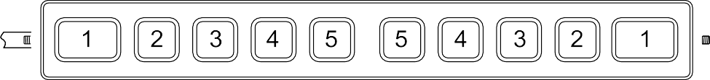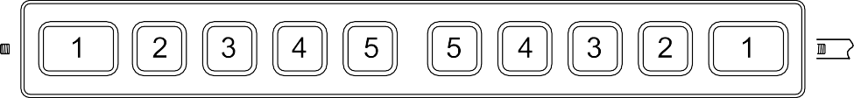

LEFT RIGHT LEFT RIGHT

Please Note:
L = Latching M = Momentary, please tick the box next to the appropriate key number if required. The key colour is created by the LED shining behind the key, please specify the colour required.
Keep words as short as possible and abbreviate long words, if an abbreviation is not stated we will insert a standard abbreviation.
Cable entry and button numbering will remain in the same position regardless of orientation please tick the appropriate box to specify cable entry.
Please complete this sheet and return it to Standby UK. Orders will not be processed until a signed copy is returned.
Customer: |  |  | Contact: |  | Signature:
Tel: | Fax: |  |  | Email: |  | Date:
C-10782-A_HW-11.02.26

